TITLE OF THE PAPER (Times New Roman - TNR 14 pt Bold)
(TNR 10 pt)
First A. Author¹, Second B. Author², Third C. Author³, …(TNR 11 pt Bold)
¹ Institution, Address, City, COUNTRY, e-mail (TNR 10 pt)
² Institution, Address, City, COUNTRY, e-mail (TNR 10 pt)
(TNR 10 pt)
(TNR 10 pt)
Abstract (TNR 9 pt Bold): The length of abstract 10 line max., type of font TNR, 9 points normal, left and right centered.
Keywords (TNR 9 pt Bold): keywords 1, keywords 2, keywords 3, keywords 4, keywords 5 (max. 5 TNR 9 pt)
(TNR 10 pt)
(TNR 10 pt)
(TNR 10 pt)
1. INTRODUCTION (Title of chapter TNR 11 pt Bold)
(TNR 10 pt)
These are the guidelines for writing the paper for the 8th International Professional and Scientific Conference Occupational Safety and Health. They are written in the format that is being described. Please follow these instructions.
(TNR 10 pt)
(TNR 10 pt)
2. TECHNICAL REQUIREMENTS
(TNR 10 pt)
The paper should be written in English (Times New Roman – TNR 10 pt normal).
Text editor: Microsoft Word.
Paper length is limited to 6 (six) pages.

2.1. Format

Use B5 (176x250 mm) page (by ISO 216 and ISO 478) format with margins (mm): 25 top, bottom, left and right.
2.2. Tables

Each table is numbered. Table caption is in TNR 10 pt, placed above the table, centered and has the following style.

Table 1: Table caption
Column 1 | Column 1 | Column 1
Row 1 | Row 1 | Row 1
Row 2 | Row 2 | Row 2
Row 3 | Row 3 | Row 3

2.3. Figures

Figures should be numbered. Please do not insert text boxes over the figures. Figure caption is in TNR 10 pt, placed below the figure, centered and has the following style:
(TNR 10 pt)
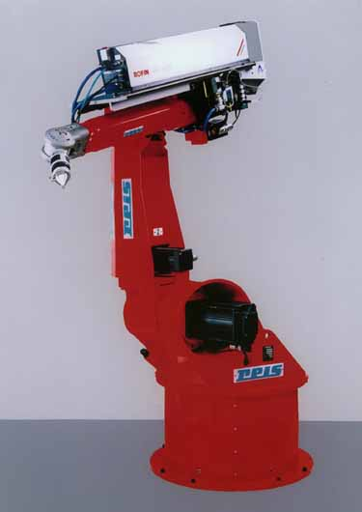
Figure 1: Figure caption

2.4. Equations

Equations are left justified 5 mm from margin with equation number at the right margin in font TNR 10 pt Italic.
$R_{a}=\text{ 0,65}⋅R_{\text{max}}^{\text{0,9}}$ (1)

3. CONCLUSION

Paper delivered after the deadline or in incorrect form shall not be published in the Book of Proceedings.

REFERENCES

References should be indicated in the text using consecutive numbers in square brackets, e. g. [1]. In the bibliography (by ISO 690) they should be cited including the title of the paper:

- Surname, N.; Surname, N.: Name of Book (in Italics), Publisher, ISBN, Place of Publication, (YYYY)
- Surname, N. & Surname, N.: Name of paper or Chapter, In Name of Book (in Italics), Publisher, ISBN, Place of Publication, (YYYY), pp. xxx-yyy
- Surname, N.; Surname, N. & Surname, N.: Title of conference paper, Proceedings of xxx xxx, Surname, N. (Ed.), pp. xxx-yyy, ISBN, conference location, Month and Year, Publisher, City, (YYYY)
- Surname, N.: Name of paper, Name of Journal (in Italics), Vol. (YYYY) No., pp. xxx-yyy, ISSN
- Surname, N.; Surname N. & Surname N.: Name of Paper, Available from http://www.exact-address-of-site Accessed: YYYY-MM-DD.

Please save your paper as ZRZZ_2024_Paper_Surname.doc written according to the provided guidelines and submit it using the online upload form no later than May 24, 2024.

